**AI Powered Quiz Generator**

**DISSERTATION**

SUBMITTED IN PARTIAL FULFILLMENT OF THE REQUIREMENTS FOR THE AWARD OF THE DEGREE OF

Master in Computer Science and Applications (M.C.A.)



By

**Suhail Khan**

**23CAMSA162**

**GL6111**

Under the supervision of

**Prof. Suhel Mustajab**

DEPARTMENT OF COMPUTER SCIENCE

ALIGARH MUSLIM UNIVERSITY

ALIGARH (INDIA)

2025

# **CERTIFICATE**

# **ACKNOWLEDGMENT**

First of all, I acknowledge my gratitude to Almighty God for enlightening me with the power of knowledge. It is great pleasure to welcome this opportunity to extend my heartfelt thanks and a sense of gratitude to everybody who helped me throughout the successful completion of this project/dissertation.

This Project/Dissertation is our cordial effort and our supervisor’s initiative and constant motivation. Special thank goes to our honorable Supervisor, **Prof. Suhel Mustajab**, Department of Computer Science, Aligarh Muslim University, for this enormous support. His excellent supervision and constant support make this project possible. We are very grateful to him for giving us the opportunity to work with him.

Next, we must thank and acknowledge our department, Department of Computer Science, Aligarh Muslim University. We also want to thank our classmates and other students of the department who took part in research purpose for our project and appreciated our work.

This acknowledgement will be incomplete if I fail to express my deep sense of obligation to my parents whom constant encouragement has always been the main source of inspiration of my life and academic endeavors.

# **ABSTRACT**

**AI Powered Quiz Generator**

The **AI Powered Quiz Generator** is a Python-based system designed to automate the generation of multiple-choice questions (MCQs) from educational PDF documents using **Natural Language Processing (NLP)** and **Generative AI** technologies. By leveraging AI models such as OpenAI’s GPT or Google’s Gemini, the system intelligently extracts meaningful content and transforms it into structured assessments without manual intervention.

The project architecture integrates key components including **PDF parsing**, **prompt engineering**, **AI-driven question generation**, and **JSON-based output formatting**. These modules operate within a unified backend, exposed through a **Flask-based RESTful API**, allowing seamless integration with Learning Management Systems (LMS), mobile applications, or custom educational platforms.

This application significantly reduces the time and effort involved in manual quiz creation, enhances learner engagement, and provides a scalable solution for generating educational assessments. Its modular design ensures adaptability across academic institutions, corporate training programs, and self-paced e-learning environments—demonstrating the potential of AI to transform traditional educational workflows.

**Table of Contents**

**CERTIFICATE** 1

**ACKNOWLEDGMENT** 2

**ABSTRACT** 3

**1.** **INTRODUCTION**‎ ‎ ‎ ‎ 2

1.1 Computer Applications and Importance 2

1.2 Present State of the Art and Its Shortcomings 3

1.3 Realization of the Problems 4

1.4 Introduction of the Problem 5

1.5 Broad Outline of the Work 6

**2.** **PROBLEM FORMULATION** 9

2.1 Problem Definition – Detailed Description 9

2.2 Various Aspects of the Problem 10

2.3 Present System – Critical Review 11

2.4 Scientific Novelty and Need for the Work 13

2.5 Proposed Method of Solution 15

**3.** **SYSTEM ANALYSIS AND DESIGN** 18

3.1 System Development Tools 18

3.2 Overview of System Analysis 19

3.2.1 System Study 19

3.2.2 Problems in the Existing System 20

3.3 Front-End Tool 21

3.4 Back-End Tools 22

Python 22

Flask 22

PyMuPDF (fitz) 23

OpenAI / Gemini APIs 23

3.5 Introduction to Database 24

3.6 Requirement Specification 25

3.6.1 Functional Requirements 25

3.6.2 Non-Functional Requirements 26

3.7 Information Collection 26

Study of Current Educational Assessment Practices 26

Consultation with Faculty and Academic Peers 27

Analysis of Existing Tools and Platforms 27

Technical Research and Feasibility Study 27

3.8 Analysis and Development of Actual Solution 28

**4.** **SYSTEM IMPLEMENTATION AND TESTING** 30

4.1 Hardware Requirements 30

4.2 Software Requirements 30

4.3 Input Requirements 30

4.4 System Testing 31

4.4.1 Testing Process 32

4.5 Implementation Summary 33

**5.** **Scope and Conclusion** 35

5.1 Scope of the Work 35

5.2 Advantages and Special Features of the System 36

5.3 Applications of the System 37

5.4 Limitations of the System 38

5.5 Future Extensions 39

5.6 Conclusion 41

**6.** **Reference and Bibliography** 43

6.1 References 43

6.2 APPENDIX 43

A1: Entity Relationship Diagram 43

A2: Use Case Diagram 46

A3: Data Flow Diagram 49

A4: Class Diagram 51

A5: Activity Diagram 53

A6: High-Level Architecture Overview 56

A8: Sample Output and Screens 56

*Chapter -1*

**‎ ‎ ‎ ‎ ‎ ‎ INTRODUCTION‎ ‎ ‎ ‎ ‎ ‎**

# **INTRODUCTION**‎ ‎ ‎ ‎

### **1.1 Computer Applications and Importance**

Computers have evolved into indispensable tools in the modern digital era, influencing and reshaping nearly every facet of human activity. Their applications extend across a multitude of domains such as healthcare, business, finance, communication, governance, and most notably, education. The transformative impact of computer applications on the educational landscape is particularly profound, as they have redefined how knowledge is delivered, accessed, and assessed.

In the academic realm, computers have enabled a significant shift from conventional, instructor-centered pedagogies to more dynamic, learner-centric environments. The integration of digital tools has not only enhanced the efficiency of instructional methodologies but has also expanded the scope and accessibility of educational resources. Platforms such as Learning Management Systems (LMS), virtual classrooms, computer-based testing, and online content delivery mechanisms exemplify the pervasive influence of computers in modern education.

Among these innovations, the application of **Artificial Intelligence (AI)** represents a substantial advancement. AI technologies have made it possible to automate repetitive and time-intensive educational tasks such as content generation, quiz formulation, grading, and real-time feedback delivery. These AI-driven systems can analyse learning materials, extract relevant knowledge, and autonomously create assessment instruments tailored to specific topics or learner levels.

In the context of assessment, AI-powered tools significantly enhance both scalability and reliability. They allow educators to focus more on conceptual engagement and curriculum enhancement, rather than investing time in the mechanical creation of tests. Moreover, the consistency provided by AI-generated quizzes ensures standardized evaluation, while their adaptability supports personalized learning trajectories.

Thus, the integration of AI within educational computing exemplifies a critical evolution—shifting the focus from manual labour to intelligent automation. This not only increases academic productivity but also aligns with global trends toward digital transformation in education.

### **1.2 Present State of the Art and Its Shortcomings**

The current landscape of quiz generation in educational institutions remains predominantly manual and labour-intensive. Educators are frequently tasked with the repetitive process of formulating questions from course materials such as textbooks, lecture presentations, and academic references. This manual approach not only consumes a considerable amount of time and effort but also introduces variability in question quality and consistency, especially when applied across diverse subjects and learner groups.

While several digital platforms—such as **Google Forms**, **Kahoot!**, and **Quizizz**—have gained popularity for hosting quizzes and promoting interactive learning experiences, these tools are largely limited to quiz delivery rather than intelligent creation. They provide interfaces to design, share, and evaluate quizzes, yet they rely entirely on human input for content creation. These platforms lack the ability to autonomously analyse academic content and derive meaningful questions from it.

The existing systems exhibit several key limitations:

* **Manual Question Creation**: All questions must be manually crafted and entered by the instructor. This process is not only repetitive but also inefficient when applied to large volumes of educational content or multiple class sections.
* **Lack of Contextual Understanding**: The questions generated are not dynamically derived from the semantic structure or contextual flow of the source material. As a result, quizzes may overlook core concepts or overemphasize peripheral details.
* **Minimal Integration with Artificial Intelligence**: Most current systems do not utilize Natural Language Processing (NLP) or large language models (LLMs) to interpret and engage with educational content at a conceptual level. This results in a disconnect between instructional materials and assessment tools.
* **Low Adaptability and Scalability**: Existing tools do not adapt quiz complexity or question types based on the depth of the content or the learner’s proficiency level. Furthermore, they do not support scalable automation for high-volume or multi-course quiz generation.

### **1.3 Realization of the Problems**

With the proliferation of digital learning materials such as PDFs, e-books, academic slide decks, and online courseware, modern education has embraced content digitization at an unprecedented scale. However, the rapid adoption of these digital resources has not been matched by a corresponding evolution in assessment tools capable of interpreting and utilizing this content for automated evaluation.

Educators increasingly find themselves burdened with the manual task of designing assessments from vast volumes of unstructured or semi-structured content. This growing gap between **content availability** and **assessment automation** presents several recurring challenges:

* **Extracting Meaningful Questions from Unstructured Documents**: Digital documents often lack standardized formatting. Extracting contextually relevant, pedagogically sound questions from such materials remains a complex task, particularly without the aid of intelligent parsing tools.
* **Ensuring Pedagogical Consistency in Quizzes**: When quizzes are created manually, there is a risk of variability in question difficulty, topic distribution, and learning objective alignment across different classes or instructors.
* **Repetition Across Semesters or Courses**: Instructors often repeat the same content delivery in multiple batches or academic cycles. Without an automated solution, the quiz preparation process must be repeated, leading to inefficiencies and duplication of effort.
* **Maintaining Assessment Quality Without Manual Review**: High-quality assessments require rigorous manual review, which is time-consuming and resource-intensive. In the absence of automated validation mechanisms, ensuring consistency and accuracy becomes a challenge.

These issues underscore the critical need for a system that can intelligently process digital learning content and autonomously generate assessment materials. Leveraging advancements in **Natural Language Processing (NLP)** and **Artificial Intelligence (AI)**, such a system can identify key concepts, formulate meaningful questions, and present them in structured formats suitable for evaluation.

By automating quiz generation, the proposed solution not only minimizes educator workload but also introduces scalability and standardization to academic assessment practices. This marks a significant step toward building intelligent educational tools that align with the future of digital and adaptive learning.

### **1.4 Introduction of the Problem**

The project entitled **"AI Powered Quiz Generator"** is conceived as a solution to the growing inefficiencies and redundancies associated with manual quiz creation in academic settings. Despite the increasing use of digital educational content—such as PDF-based lecture notes, textbooks, and reading materials—there remains a lack of intelligent tools that can seamlessly convert these documents into structured assessments. As a result, educators must repeatedly invest significant time and effort in designing quizzes that are both relevant and pedagogically sound.

This project proposes the development of a **Python-based web application** capable of automating the quiz generation process through the integration of PDF parsing techniques and advanced language models. The system is designed to perform the following operations in a streamlined and user-friendly manner:

* Accept PDF files through a web-based or API-driven interface.
* Extract and clean content using tools like PyMuPDF for accurate text retrieval.
* Generate multiple-choice questions (MCQs) by leveraging AI-powered language models (e.g., OpenAI or Gemini), which interpret the content and formulate contextually relevant questions.
* Return the final output in a structured **JSON format**, suitable for storage, review, or integration with third-party platforms.

The backend functionality is powered by the **Flask microframework**, which enables efficient routing of HTTP requests and facilitates seamless integration with Learning Management Systems (LMS) and other educational tools. While the core system operates as a backend API, an optional frontend component provides an intuitive interface for direct interaction and testing.

The primary objective of the project is to **simplify the quiz creation process for educators**, thereby allowing them to focus on conceptual instruction rather than content assessment logistics. By ensuring that the generated questions are semantically aligned with the input material, the system enhances both the **accuracy** and **scalability** of educational evaluations. Moreover, it contributes to the broader vision of integrating AI into instructional design and automated learning environments.

### **1.5 Broad Outline of the Work**

The development of the **AI Powered Quiz Generator** is guided by a modular and structured workflow designed to automate the transformation of academic documents into intelligently generated assessments. The project architecture incorporates various functional components, each playing a distinct role in ensuring that the final output is contextually accurate, pedagogically meaningful, and technically accessible.

The system encompasses the following key functionalities:

* **PDF Document Upload and Pre-processing**  
  Users can upload academic PDF documents through a web interface or REST API endpoint. The system validates the file format and prepares it for further processing.
* **Text Extraction and Segmentation**  
  Utilizing libraries such as **PyMuPDF**, the system extracts raw textual content from the uploaded PDF. The extracted content is then segmented into meaningful units (such as paragraphs or topics) to support accurate question generation.
* **NLP-Based Prompt Engineering**  
  The segmented text is processed using Natural Language Processing (NLP) techniques to identify key information and construct a prompt that guides the language model in generating high-quality questions. This step ensures relevance and contextual integrity in the generated content.
* **AI-Generated Question Formation (MCQs)**  
  The engineered prompt is passed to an AI model (e.g., OpenAI or Gemini) that returns multiple-choice questions based on the source material. The questions are generated with appropriate distractors and correct answers, aligned with the learning objectives implied in the content.
* **JSON Output Formatting**  
  The generated questions are structured into a **JSON** format, making them easily readable by machines and compatible with external platforms. This format includes metadata such as question ID, options, and correct answers.
* **Flask Server Integration for API Accessibility**  
  The entire backend logic is encapsulated within a **Flask-based API**, allowing third-party systems or user interfaces to interact with the quiz generator through HTTP requests. This enables seamless integration into Learning Management Systems (LMS), content delivery platforms, or mobile apps.
* **Support for Modular and Scalable Architecture**  
  The system is designed with modularity in mind, enabling the independent development and scaling of each component. This architecture supports future enhancements such as multilingual question generation, difficulty adjustment algorithms, or database-backed persistence.

*Chapter -2*

**‎ PROBLEM FORMULATION‎**

# **PROBLEM FORMULATION**

### **2.1 Problem Definition – Detailed Description**

The creation of quizzes from educational material is a fundamental component of curriculum delivery and student assessment. However, when the source material is in unstructured digital formats—such as PDF documents, scanned notes, or e-books—the quiz creation process becomes a labor-intensive task. Educators must invest significant effort in identifying key concepts, drafting appropriate multiple-choice questions (MCQs), and ensuring that each question aligns with the intended learning outcomes. This process requires both subject-matter expertise and time, making it increasingly unsustainable in fast-paced, large-scale academic environments.

Despite the widespread digitization of instructional materials across schools, colleges, and training institutions, the assessment creation process has remained largely static. Current workflows involve manually reading entire documents, highlighting examinable content, and formulating questions by hand. The repetitive nature of this task, coupled with the increasing volume of digital content, underscores the inefficiencies inherent in traditional quiz development practices.

Although recent advancements in **Natural Language Processing (NLP)** and **Large Language Models (LLMs)** such as OpenAI's GPT and Google's Gemini have demonstrated the capacity to understand and generate human-like language, these technologies are underutilized in educational assessment automation. Existing quiz platforms may support quiz hosting and evaluation but fall short when it comes to automatically interpreting raw educational documents and producing pedagogically meaningful questions.

There exists a notable gap in systems that can perform end-to-end automation—from content ingestion to quiz generation—while ensuring contextual relevance and reusability. Specifically, there is a lack of tools that can output structured data formats such as **JSON**, which are essential for integration into Learning Management Systems (LMS), adaptive learning environments, or further customization pipelines.

This project aims to address this gap by developing an **AI-powered quiz generation system** that can:

* Accept academic PDF files as input,
* Parse and extract clean text content using Python-based tools (e.g., PyMuPDF),
* Construct intelligent prompts for AI models using NLP techniques, and
* Generate MCQs with corresponding options and answers via calls to advanced LLMs.

The output is formatted in JSON, enabling easy deployment, storage, integration, and user-level customization. The goal is to significantly reduce the manual workload associated with quiz creation, while simultaneously enhancing the scalability, consistency, and pedagogical quality of assessments across digital learning environments.

### **2.2 Various Aspects of the Problem**

The manual creation of quizzes from academic materials is a multifaceted challenge, shaped by pedagogical, operational, and technological constraints. While assessments are essential to evaluating student understanding and reinforcing learning, their design process—especially from unstructured documents like PDFs—poses several critical hurdles. These challenges not only affect the efficiency of educators but also impact the consistency and quality of academic evaluations. The major aspects contributing to the complexity of manual quiz generation include the following:

* **Time and Resource Intensive**  
  Creating quizzes manually is a laborious process, particularly when dealing with lengthy or dense academic documents. Educators must allocate considerable time to read, comprehend, and extract examinable material, formulate well-structured questions, and review them for accuracy and relevance. This repetitive workload detracts from their ability to focus on higher-level instructional tasks such as mentoring or curriculum development.
* **Inconsistency in Quality**  
  The quality of manually created quizzes often varies based on the instructor’s individual expertise, interpretation, and time availability. This leads to inconsistencies in the level of difficulty, formatting, and alignment with learning outcomes. Such variability can affect the fairness and reliability of student assessments, especially in multi-instructor or large-scale learning environments.
* **Scalability Issues**  
  As the volume of educational content and the number of enrolled students grow, the manual approach becomes increasingly unsustainable. Institutions offering multiple courses or operating in batch-wise academic models face significant difficulties in maintaining quiz banks for repeated use across semesters or sections.
* **Lack of Contextual Relevance**  
  Manually generated questions may not always reflect the core concepts or learning objectives embedded in the source content. Without the support of AI or NLP tools, educators may unintentionally overlook key topics or overemphasize minor details, leading to assessments that are misaligned with instructional goals.
* **Limited Reusability and Integration**  
  In many cases, the output from manual quiz generation is stored in static formats such as PDFs, Word documents, or spreadsheets. These formats are not inherently machine-readable or platform-independent, limiting their reusability and integration into digital ecosystems such as Learning Management Systems (LMS), mobile applications, or adaptive testing tools.

### **2.3 Present System – Critical Review**

In the current educational technology landscape, numerous platforms such as **Google Forms**, **Moodle**, **Blackboard**, and **Quizizz** have been widely adopted for the creation, distribution, and grading of quizzes. These tools have facilitated the digital transformation of assessments by offering user-friendly interfaces, customizable templates, and integration with Learning Management Systems (LMS). However, a critical evaluation reveals that these systems focus primarily on **quiz delivery**, rather than **quiz generation**.

Most existing systems share the following limitations:

* **Manual Question Input**  
  These platforms rely entirely on users—typically educators—to manually compose and input questions. This approach reintroduces the core inefficiencies associated with traditional assessment creation, including time consumption, redundancy, and inconsistency in question quality.
* **Lack of Document Comprehension**  
  Current systems are not capable of interpreting academic documents such as PDFs, lecture slides, or textbooks. They cannot extract meaningful content or derive questions from it autonomously, thus requiring educators to bridge the gap between instructional material and assessment manually.
* **Limited Question Templates and Rigid Structure**  
  The range of question formats offered is often restricted to basic multiple-choice, true/false, or short-answer questions. Furthermore, the absence of intelligent question adaptation mechanisms prevents these platforms from tailoring content to learner profiles or varying levels of difficulty.
* **No Integration with NLP or Large Language Models (LLMs)**  
  Existing tools do not incorporate advanced **Natural Language Processing (NLP)** or **Large Language Models** to generate contextually rich and grammatically correct questions. Consequently, they lack the ability to understand deeper semantic patterns or educational relevance embedded in source materials.

Even among platforms that attempt semi-automation, the underlying mechanisms are simplistic—typically based on keyword extraction, rule-based systems, or basic heuristics. Such methods fall short in capturing the nuance, structure, and pedagogical flow of the original content, resulting in **low-quality** or **out-of-context** assessments.

### **2.4 Scientific Novelty and Need for the Work**

The scientific novelty of this project lies in its integrated, end-to-end approach to **intelligent quiz generation** using a combination of modern computational techniques and scalable software architecture. While isolated components such as text extraction, AI model querying, or quiz hosting are individually well-understood, the **fusion of these components into a unified, automated pipeline** for educational assessment marks a novel contribution in the field of educational technology.

The proposed system introduces the following innovative elements:

* **Automated Text Extraction Using PyMuPDF**  
  Instead of relying on structured input, the system processes unstructured PDF documents using the PyMuPDF library. This enables accurate and fast extraction of raw textual data from academic content, which is critical for downstream processing.
* **Prompt Engineering for AI Models**  
  A key novelty lies in crafting context-aware prompts that can guide large language models (LLMs) such as OpenAI’s GPT or Google’s Gemini to produce relevant, well-structured multiple-choice questions. This process involves segmentation, keyword identification, and syntactic refinement—tasks typically handled manually.
* **Contextual Interpretation via NLP**  
  The system leverages NLP techniques to ensure that only contextually meaningful segments of the text are selected for quiz generation. This reduces noise, improves content relevance, and aligns the generated questions with educational learning objectives.
* **JSON-Based Structured Output**  
  The output of the system is returned in a standardized **JSON format**, which makes it compatible with a wide range of digital platforms. This enhances interoperability with Learning Management Systems (LMS), dashboards, mobile apps, or third-party assessment tools.
* **Flask-Based API for Seamless Integration**  
  The backend is encapsulated within a **Flask-based RESTful API**, allowing for modular deployment and easy integration into existing digital infrastructures. This architectural choice supports both standalone use and embedding into larger educational ecosystems.

Together, these components create a **flexible and intelligent workflow** for quiz generation, capable of transforming raw academic content into structured assessments with minimal human involvement. The system is optimized for both academic institutions and e-learning platforms, making it a versatile solution for modern education environments.

The **need for this work** is driven by multiple converging trends:

* **The Widespread Shift to Digital Education**  
  As educational content continues to move online, there is an increasing demand for systems that can automate auxiliary tasks like assessment creation to maintain scalability and efficiency.
* **The Rise of AI in Content Creation and Evaluation**  
  Artificial Intelligence is rapidly transforming how content is produced and consumed in education. However, few systems have effectively leveraged AI for personalized, document-driven assessment generation.
* **The Lack of Scalable, Intelligent Assessment Tools**  
  Despite the availability of LMS platforms, there remains a shortage of tools that can automatically convert instructional content into high-quality, contextually valid quizzes. Most existing tools still require manual input and lack adaptability.

This project addresses these unmet needs by offering a scientifically robust, technically viable, and educationally impactful solution.

### **2.5 Proposed Method of Solution**

To address the challenges associated with manual quiz creation and to overcome the limitations of existing systems, the **AI Powered Quiz Generator** employs a modular, step-by-step methodology that integrates advanced tools and technologies. The proposed solution leverages document parsing, Natural Language Processing (NLP), and Large Language Models (LLMs) to automate the generation of high-quality multiple-choice questions (MCQs) from unstructured academic content.

The core methodology consists of the following stages:

* **Step 1: PDF Upload and Parsing**  
  The user uploads an academic PDF document via a web form or API endpoint. The system utilizes **PyMuPDF**—a lightweight and efficient PDF parsing library in Python—to extract plain textual content from the document. This raw content forms the input for subsequent processing stages.
* **Step 2: Text Preprocessing and Cleaning**  
  The extracted text often includes headers, footers, page numbers, and other artifacts. A preprocessing module is employed to normalize the content, remove irrelevant elements, and segment it into semantically meaningful sections. This ensures that only pedagogically useful information is retained.
* **Step 3: Prompt Formation**  
  A context-aware prompt is constructed using selected text segments. This prompt is formatted specifically to instruct the language model (e.g., “Generate 5 MCQs from the following content...”). The goal is to guide the LLM toward producing questions that are relevant, clear, and balanced in difficulty.
* **Step 4: AI Invocation**  
  The system invokes a **Large Language Model (LLM)**—such as **OpenAI’s GPT** or **Google’s Gemini**—through secure API calls. The prompt is submitted to the model, which processes the input and returns a list of multiple-choice questions, each consisting of a question stem, a set of options, and a correct answer.
* **Step 5: JSON Formatting**  
  The response received from the AI model is parsed and formatted into a structured **JSON object**. Each MCQ is encapsulated with appropriate metadata, such as question ID, content, options, and answer key. This format ensures compatibility with third-party applications and simplifies data storage, editing, or export.
* **Step 6: Output Delivery via Flask API**  
  The final JSON output is returned through a **Flask-based API endpoint**, enabling real-time interaction with the system. This API-first design allows the application to be easily integrated with Learning Management Systems (LMS), mobile apps, or other educational platforms.

This **modular and scalable architecture** promotes clarity and separation of concerns, making it easier to debug, maintain, and extend the system. Additionally, the methodology is adaptable—future iterations can support alternative input formats (e.g., DOCX, HTML) and integrate with emerging AI models without altering the fundamental pipeline.

The subsequent chapter provides a detailed overview of the technologies used, system architecture, and module-wise implementation of the proposed solution.

*Chapter -3*

**SYSTEM ANALYSIS AND DESIGN**

# **SYSTEM ANALYSIS AND DESIGN**

### **3.1 System Development Tools**

The development of the **AI Powered Quiz Generator** leverages a diverse set of modern technologies, each selected to fulfill a specific function within the system’s architecture. These tools are strategically combined to enable seamless backend processing, effective AI integration, and optional frontend interaction. Together, they form a robust and scalable ecosystem for automated quiz generation.

The primary development tools used in the project include:

* **Python**  
  Python serves as the core programming language for the system. Its simplicity, extensive library support, and high readability make it ideal for implementing backend logic, integrating APIs, and performing Natural Language Processing (NLP). Python’s compatibility with various AI platforms also enhances its suitability for experimental and production-level development.
* **Flask**  
  Flask is employed as the backend web framework for developing the RESTful API server. Its lightweight and modular nature allows for rapid development and deployment of endpoints used to handle file uploads, process data, and return quiz outputs. Flask also supports scalability and easy integration with frontend or external client systems.
* **PyMuPDF (fitz)**  
  This library is responsible for parsing and extracting content from uploaded PDF documents. It allows for fast and precise retrieval of text from academic materials, making it a critical component in the preprocessing pipeline. PyMuPDF is chosen for its reliability in handling diverse PDF structures and encodings.
* **OpenAI / Gemini API**  
  These APIs are used to access powerful Large Language Models (LLMs) capable of interpreting educational text and generating multiple-choice questions. The system sends intelligently constructed prompts to the model and receives grammatically sound, contextually accurate questions in return. Both models offer flexibility, multilingual support, and scalable performance.
* **Jupyter Notebooks**  
  Jupyter Notebooks are utilized during the development phase for prototyping and experimenting with prompt structures, testing API responses, and refining logic. Their interactive interface allows for rapid iteration and real-time debugging during AI model integration.
* **HTML / CSS (Optional)**  
  Although the system primarily operates as a backend API, a minimal web interface is developed using HTML and CSS to allow testing and demonstration. This optional interface enables users to upload PDF files and view the generated quiz in a human-readable format.
* **JSON (JavaScript Object Notation)**  
  JSON is used as the primary output format for quiz data. It is lightweight, human-readable, and easily parsed by machines. The structure includes fields for questions, options, and correct answers, making it suitable for integration into Learning Management Systems (LMS) or custom educational platforms.

### 3.2 Overview of System Analysis

#### **3.2.1 System Study**

The traditional method of quiz creation in academic environments is largely manual and demands significant educator involvement. Instructors must routinely generate new quizzes for each subject, topic, or academic term. This repetitive process includes reading and interpreting course materials, identifying important concepts, crafting suitable multiple-choice questions (MCQs), and manually formatting them for delivery or storage.

As educational institutions increasingly adopt digital resources—particularly in the form of **PDF documents**, such as lecture notes, textbooks, and e-books—there arises a significant opportunity to modernize and streamline assessment workflows. Despite the abundance of digital content, the tools available for transforming these resources into evaluative materials remain underdeveloped.

The **AI Powered Quiz Generator** is developed in response to this gap. It systematically identifies inefficiencies in the current quiz preparation workflow and introduces automation through the integration of **Artificial Intelligence (AI)** and **Natural Language Processing (NLP)**. By parsing academic PDFs and generating context-aware MCQs, the system reduces human effort, improves consistency, and enhances scalability in educational assessment.

This design aims to empower educators by eliminating tedious manual steps while preserving the quality and contextual accuracy of the questions generated. The system functions as a backend API that can be easily integrated with existing platforms or used as a standalone tool for automated quiz generation.

#### **3.2.2 Problems in the Existing System**

The manual nature of conventional quiz creation processes introduces several limitations that hinder both educational effectiveness and operational efficiency. Key issues identified in existing systems include:

* **Lack of Automated Quiz Generation**  
  Most educational platforms do not support the automatic generation of questions from instructional content. Educators must create each quiz item from scratch, regardless of the similarity in content across different sessions or learner groups.
* **Inconsistencies and Human Error**  
  Manual processes are inherently prone to variability in question quality, alignment with learning outcomes, and difficulty levels. Inconsistencies may also arise from differing instructor interpretations or time constraints.
* **Absence of NLP and AI Integration**  
  Contemporary systems generally lack integration with NLP frameworks or large language models (LLMs), making it impossible to interpret documents intelligently or generate semantically meaningful assessments.
* **Scalability Constraints**  
  As class sizes grow and educational programs diversify, maintaining a manual approach becomes increasingly unsustainable. The lack of scalability limits the ability of institutions to deliver consistent assessments across courses or semesters.
* **Time-Consuming and Repetitive Tasks**  
  Educators often spend valuable instructional time on redundant tasks such as rewriting questions or revising existing quizzes for new batches, thereby reducing the time available for personalized teaching and student engagement.

These challenges reinforce the need for an intelligent, AI-driven solution that addresses the core inefficiencies in quiz preparation and provides a path toward scalable, automated, and contextually rich assessment design.

### 3.3 Front-End Tool

**Although the system primarily operates as a backend API service, it can be extended to include a lightweight frontend interface developed using standard web technologies such as HTML, CSS, and JavaScript. This optional frontend component is particularly useful for testing, demonstration, and user interaction purposes.**

The proposed web interface provides a user-friendly platform for uploading PDF documents directly through a browser. Once a file is selected and submitted via the form, it is sent to the Flask backend using a POST request. The backend then processes the uploaded document, extracts the relevant content, and uses a large language model (such as OpenAI or Gemini) to generate multiple-choice questions. The resulting quiz is structured in a JSON format and returned as a response.

This output can be displayed in two formats:

1. **Raw JSON view**: Useful for developers and system integrators who want to examine or further process the structured data.
2. **Interactive quiz rendering**: Where the JSON response is dynamically parsed and transformed into a visually formatted quiz interface using JavaScript. Users can view, attempt, and even submit responses directly from the interface.

Integrating such a frontend not only enhances the accessibility and usability of the system for non-technical users but also serves as a valuable tool for demonstrating the functionality during academic reviews, stakeholder presentations, or deployment evaluations. Furthermore, it lays the groundwork for future expansion into full-fledged Learning Management Systems (LMS) or integration into existing educational platforms.

### 3.4 Back-End Tools

The backend of the **AI Powered Quiz Generator** is designed using robust, scalable technologies to ensure efficient processing and accurate question generation. The following tools and libraries constitute the core of the backend implementation:

#### **Python**

Python serves as the primary development language for this project. It is chosen due to its simplicity, readability, and powerful ecosystem of libraries for data processing, artificial intelligence, and application development. Python enables rapid prototyping and seamless integration with third-party APIs and NLP frameworks. Its strong community support and cross-platform compatibility make it an ideal choice for backend systems that require advanced computational tasks such as text extraction, prompt engineering, and API interaction.

#### **Flask**

Flask, a lightweight and flexible micro web framework in Python, is employed to develop the RESTful API that connects the frontend interface (or external systems) with the backend processing logic. It is responsible for handling:

* HTTP request routing
* File upload endpoints
* Data validation
* Response management in structured formats (e.g., JSON)

Due to its modular architecture, Flask simplifies the process of building, testing, and deploying web APIs, making it highly suitable for academic and production environments.

#### **PyMuPDF (fitz)**

PyMuPDF, imported as fitz, is the core library used for parsing and processing PDF documents. It provides efficient tools to:

* Open and read PDF files
* Extract plain text content from each page
* Clean and aggregate text into a single continuous input

This library is known for its speed and precision in handling PDF layouts, ensuring that educational content is correctly captured and forwarded to the AI generation module. It supports a wide range of PDF encodings and is highly reliable even for large and complex documents.

#### **OpenAI / Gemini APIs**

To generate quiz questions automatically, the system leverages the capabilities of large language models via APIs such as **OpenAI’s GPT** or **Google’s Gemini**. These advanced models are accessed using secure API keys, and they interpret instructional prompts crafted from the uploaded document's content. Key capabilities include:

* Understanding context and semantics of the source material
* Generating multiple-choice questions with distractors
* Producing grammatically correct and educationally valid outputs

These APIs form the intelligence core of the system, enabling the transformation of static content into dynamic, learner-focused assessments.

### 3.5 Introduction to Database

The current implementation of the **AI Powered Quiz Generator** does not incorporate a persistent database for storing user data or intermediate outputs. Instead, the system is architected to function in a **stateless, in-memory** mode. This design choice aligns with the lightweight and API-driven nature of the application, where the primary objective is to process individual PDF documents and return a corresponding quiz in real-time.

Upon receiving a PDF file via the web interface or API endpoint, the system performs the following actions sequentially:

1. Extracts textual content from the PDF.
2. Constructs a structured prompt for the language model.
3. Sends the prompt to the AI engine (e.g., OpenAI or Gemini).
4. Receives and parses the response into quiz-format questions.
5. Formats the output as a structured JSON object.
6. Returns the JSON as part of the HTTP response.

At no point during this process is user-uploaded data or the generated quiz persistently stored on the server. This **transient processing model** enhances system privacy and reduces the overhead associated with database integration, particularly during development and testing phases.

However, the **JSON output** produced by the system is structured and well-suited for future storage or integration. It can be:

* Persisted to a database (e.g., MongoDB, PostgreSQL) in future iterations.
* Exported to flat files (JSON, CSV) for archiving or manual review.
* Integrated into third-party platforms such as LMSs or dashboards via API.

This modularity ensures that the system remains flexible and extensible. If future requirements demand persistent data storage—for purposes such as user management, quiz history, analytics, or administrative control—a dedicated database layer can be integrated without affecting the core logic.

### **3.6 Requirement Specification**

The successful design and development of the **AI Powered Quiz Generator** are guided by a set of well-defined functional and non-functional requirements. These requirements outline what the system is expected to do, as well as the standards it should maintain in terms of performance, reliability, and usability.

#### **3.6.1 Functional Requirements**

The system is expected to fulfill the following core functions:

* **Upload PDF Document**: The system shall allow the user to upload an academic PDF file containing instructional or subject-related content. The upload may occur via a web interface or API endpoint.
* **Extract and Clean Text**: Upon receiving the PDF, the system shall parse and extract readable text using PDF parsing tools. The content will be cleaned to remove unwanted characters, formatting artifacts, and irrelevant sections.
* **Generate Quiz Using AI**: Based on the cleaned content, the system shall construct a contextual prompt and forward it to an external AI model (e.g., OpenAI’s GPT or Google’s Gemini). The AI model will generate multiple-choice questions (MCQs) relevant to the extracted content.
* **Return JSON-Formatted Output**: The generated quiz, including questions, options, and correct answers, shall be formatted in a structured JSON format. This ensures compatibility with external systems and allows for easy parsing and display.
* **API Response via HTTP Request**: The system shall return the JSON output as an HTTP response to the client application or browser interface. The API will follow RESTful conventions to ensure clarity and scalability.

#### **3.6.2 Non-Functional Requirements**

In addition to the above functionalities, the system must adhere to the following non-functional specifications to ensure optimal performance and reliability:

* **Quick Response Time**: The system should be capable of generating quiz output within **five seconds or less** for standard documents (10–20 pages). This ensures usability and responsiveness in real-time applications.
* **Model-Agnostic Implementation**: The system should be designed in a modular fashion to allow integration with different AI models such as OpenAI, Gemini, or future alternatives, without significant code refactoring.
* **Secure Input Validation**: Input documents must be validated for format, size, and safety to prevent malicious uploads and ensure system stability. The system must handle errors gracefully and provide appropriate feedback for unsupported files.
* **Minimalistic User Interface (Optional)**: Although the system primarily functions as an API, an optional HTML-based user interface may be provided for demonstration and testing. This interface must be intuitive and lightweight, suitable for non-technical users.

### **3.7 Information Collection**

The information gathering process for the **AI Powered Quiz Generator** was undertaken through a combination of domain-specific research, peer consultation, and technical exploration. A systematic approach was employed to ensure that both functional and non-functional requirements were accurately identified and aligned with the real-world needs of educators and learners.

#### **Study of Current Educational Assessment Practices**

To understand the core challenges in academic assessment, a detailed review of traditional and digital quiz creation methods was conducted. This included observing how educators manually extract content from teaching materials to design quizzes, along with the time, effort, and inconsistencies involved in the process. Real-world practices in schools, colleges, and e-learning platforms were evaluated to pinpoint specific inefficiencies and bottlenecks.

#### **Consultation with Faculty and Academic Peers**

Interviews and informal discussions were held with faculty members, subject matter experts, and fellow students to gather qualitative insights. These consultations helped in identifying practical limitations of existing systems such as Google Forms, Moodle, and Quizizz. Feedback from these stakeholders was instrumental in shaping the system requirements, particularly with regard to quiz accuracy, ease of use, and content relevance.

#### **Analysis of Existing Tools and Platforms**

A comparative analysis of popular quiz platforms and Learning Management Systems (LMS) was undertaken. Their strengths and limitations were documented, with particular attention paid to their inability to autonomously generate questions from unstructured academic content. This analysis highlighted the gap that the proposed system aims to address.

#### **Technical Research and Feasibility Study**

A thorough investigation of available technologies was conducted to assess their suitability for implementing the proposed solution. Key areas of exploration included:

* **Python Libraries** for text extraction and PDF parsing, such as PyMuPDF
* **Natural Language Processing (NLP)** frameworks for text cleaning and segmentation
* **Large Language Models (LLMs)** and AI APIs (e.g., OpenAI, Gemini) for generating contextually relevant multiple-choice questions
* Web frameworks like **Flask** for building API-based systems

### 3.8 Analysis and Development of Actual Solution

The final design consists of the following core modules:

* **Text Extractor Module**: Parses and cleans PDF input
* **Prompt Generator Module**: Constructs instructional prompt for the AI
* **AI Interface Module**: Sends prompt to the language model API and receives questions
* **Response Formatter Module**: Formats results into a structured JSON response
* **API Handler Module**: Accepts file upload and returns final quiz via Flask

This modular architecture ensures maintainability, scalability, and ease of future upgrades (e.g., support for other file types or multilingual quiz generation).

The next chapter describes how this design was implemented into a functional system along with the testing procedures followed.

*Chapter -4*

**SYSTEM IMPLEMENTATION AND TESTING‎**

# **SYSTEM IMPLEMENTATION AND TESTING**

### 4.1 Hardware Requirements

* Processor: Intel Core i3 or higher
* RAM: Minimum 8GB
* Storage: 20GB available disk space
* Display: Colour monitor
* Input Devices: Standard QWERTY keyboard, Optical mouse

### 4.2 Software Requirements

* Operating System: Windows 10 or above / Linux-based OS
* Programming Language: Python 3.10+
* Libraries and APIs: Flask, PyMuPDF, requests, OpenAI/Gemini API, JSON
* Development Environment: Visual Studio Code / Jupyter Notebook / PyCharm
* Web Interface (optional): HTML/CSS
* Browser: Google Chrome / Mozilla Firefox for testing

### 4.3 Input Requirements

The effectiveness of the **AI Powered Quiz Generator** is closely tied to the quality and structure of the input data. The system is designed to accept academic documents in **Portable Document Format (.pdf)** as input, with the expectation that these files contain well-structured, subject-specific educational content.

The following constraints and conditions apply to the input:

* **File Format**: The system only supports .pdf files. Uploading documents in unsupported formats such as .docx, .pptx, or image-based PDFs will result in processing errors or invalid output.
* **Content Type**: The input PDF should contain **academic or instructional text**, such as lecture notes, textbook chapters, research summaries, or concept explanations. The system is optimized for content that lends itself to factual question generation.
* **Language Support**: The current version of the system processes only **English-language** documents. Non-English content may be parsed successfully, but the prompt construction and AI-generated questions are unlikely to maintain linguistic or semantic accuracy.
* **Formatting**: PDFs should ideally contain **plain, continuous text** with minimal graphical or tabular elements. Excessive use of tables, scanned handwritten notes, or poorly formatted text can hinder the text extraction phase, thereby impacting the relevance and coherence of generated questions.
* **Scanned or Image-based PDFs**: The system does not currently incorporate Optical Character Recognition (OCR). Therefore, **image-based or poorly scanned PDFs** are not supported and may result in empty or incoherent outputs.

### **4.4 System Testing**

Comprehensive system testing was undertaken to evaluate the functionality, reliability, and performance of the **AI Powered Quiz Generator** across its core modules. The goal of testing was to validate that the system behaves as expected under normal conditions, as well as under edge-case scenarios. The testing strategy encompassed both isolated module verification and full-system integration, ensuring that the workflow from PDF upload to quiz output met the project’s objectives for accuracy, robustness, and responsiveness.

Each subsystem—ranging from PDF parsing and text preprocessing to prompt generation, AI response handling, and output formatting—was evaluated independently (unit testing) and collectively (integration testing). Additionally, the system was assessed using realistic datasets to simulate actual user behavior, allowing for meaningful insights into its performance in academic settings.

### **4.4.1 Testing Process**

The testing process followed a structured methodology comprising the following levels:

* **Unit Testing**  
  Each individual function and module was tested in isolation to ensure logical correctness and expected output. Key unit tests included:
  + Text extraction from PDF files using PyMuPDF
  + Cleaning and normalization of text data
  + Construction of AI prompts from processed text
  + Formatting AI-generated responses into structured JSON
* **Integration Testing**  
  Modules were then tested in combination to ensure that data flowed correctly across the system. The integration of the Flask API, PDF parser, prompt builder, and AI model interface was carefully validated to confirm seamless operation of the end-to-end workflow.
* **Functional Testing**  
  A series of academic PDF documents—covering diverse topics and formats—were used to assess the real-world usability of the system. This testing focused on:
  + The relevance and clarity of generated multiple-choice questions
  + The consistency of option formatting
  + The contextual alignment between source content and generated output
* **Performance Testing**  
  The system's responsiveness was evaluated by measuring processing time across different document sizes (e.g., 2-page summaries vs. 30-page chapters). The performance metrics confirmed that the system consistently delivered results within acceptable time thresholds (typically under 5 seconds for standard documents).
* **Edge Case Testing**  
  To ensure robustness, the system was tested with a variety of challenging inputs, including:
  + Empty or near-empty PDF files
  + Scanned PDFs with minimal extractable text
  + Documents containing special characters, equations, or non-standard encodings.

### 4.5 Implementation Summary

The implementation of the **AI Powered Quiz Generator** was successfully achieved through a modular and scalable architecture built primarily using the Python programming language. Each core component of the system was developed as an independent module, with clearly defined interfaces that facilitated seamless communication and data flow across the entire pipeline.

The system begins with user interaction via a **Flask-based web API**, which accepts PDF files and initiates the backend processing sequence. The **PyMuPDF library** was utilized for reliable and efficient extraction of textual data from the uploaded documents. This extracted content was then cleaned and structured to serve as input for prompt generation.

A well-engineered prompt was created and forwarded to the **OpenAI API endpoint** (or Gemini alternative), which returned a set of multiple-choice questions (MCQs) generated in real-time. The system then parsed the AI-generated response and formatted it into a structured **JSON** format, ready for use in external applications or further customization.

All essential functionalities were validated through rigorous testing procedures, including unit testing, integration testing, performance benchmarking, and edge-case analysis. The system demonstrated high reliability, fast response times, and contextual relevance of generated questions.

The use of a RESTful API architecture ensures that the application can be easily integrated with **Learning Management Systems (LMS)**, mobile applications, and other digital education platforms. This modular design also lays the foundation for future extensions, including multilingual support, difficulty-level tuning, and graphical quiz interfaces.

The next chapter explores the broader implications of the project, highlighting its practical applications, benefits to educators and learners, system limitations, and potential directions for future research and enhancement.

*Chapter -5*

**‎‎‎‎ ‎ ‎ SCOPE AND CONCLUSION ‎ ‎**

# **Scope and Conclusion**

### **5.1 Scope of the Work**

The **AI Powered Quiz Generator** has broad and impactful applicability across various educational and training ecosystems. It directly addresses a critical gap in modern pedagogy: the need for scalable, intelligent tools that can automate the creation of high-quality assessments. By leveraging Natural Language Processing (NLP) and Large Language Models (LLMs), the system transforms unstructured educational content—particularly PDF-based documents—into structured, interactive multiple-choice assessments with minimal human intervention.

This capability holds immense value for:

* **Academic Institutions**: Colleges, universities, and schools can utilize the system to rapidly generate formative and summative assessments, saving instructors considerable time and ensuring content relevance.
* **Corporate Training Programs**: The tool can assist in the automated evaluation of training modules by generating quizzes from technical documentation, policy manuals, and onboarding materials.
* **E-Learning Platforms**: Online education providers can integrate the system into their platforms to auto-generate quizzes from course content, enabling real-time, adaptive assessments for learners.

A key strength of the system lies in its **modular and extensible architecture**. The project is not limited to PDF parsing; it can be extended to support other document formats such as .docx, .html, and even web pages. Additionally, the use of **JSON as the output format** ensures interoperability with a wide range of digital tools, including:

* Learning Management Systems (LMS)
* Mobile learning applications
* Browser-based quiz platforms
* Analytical dashboards for performance tracking

### **5.2 Advantages and Special Features of the System**

The **AI Powered Quiz Generator** offers several compelling advantages that distinguish it from traditional quiz creation workflows and existing educational platforms. Designed with efficiency, intelligence, and interoperability in mind, the system introduces automation to a process historically dominated by manual labor. Its advanced features and underlying architecture contribute to its adaptability across diverse educational contexts.

Key advantages and features include:

* **Automated Quiz Generation**  
  The system autonomously extracts key information from educational content and formulates well-structured multiple-choice questions (MCQs). This end-to-end automation minimizes human intervention, thereby streamlining the quiz development process.
* **AI Integration for Context-Aware Generation**  
  At the core of the system is the integration with **state-of-the-art language models** (such as OpenAI and Gemini). These models possess the ability to understand natural language, interpret context, and generate questions that are semantically aligned with the input content. This ensures higher relevance and pedagogical integrity.
* **Scalability Across Domains and Levels**  
  The system is designed to handle a wide variety of academic subjects and content complexities, making it suitable for use at different educational levels—from K–12 and undergraduate programs to corporate training and continuing education.
* **API Accessibility for External Integration**  
  The use of a **Flask-based RESTful API** architecture enables third-party applications, mobile platforms, and Learning Management Systems (LMS) to seamlessly connect to the system. This allows quiz data to be dynamically generated, retrieved, or integrated into external platforms.
* **Structured Output in JSON Format**  
  The questions, options, and answers are returned in a well-organized **JSON format**, allowing easy storage, customization, visualization, or transformation into other formats such as HTML or CSV. This structured representation ensures compatibility with modern digital ecosystems.
* **Significant Reduction in Manual Effort**  
  By automating time-consuming tasks, the system reduces the workload on educators and instructional designers. This enables them to allocate more time to pedagogical planning, student engagement, and curriculum development.
* **Modular and Extensible Architecture**  
  Built using a modular design philosophy, the system supports future enhancements such as:
  + Support for additional input formats (e.g., DOCX, Markdown)
  + Advanced question types (e.g., fill-in-the-blank, short answers)
  + Difficulty-level customization  
    These enhancements can be integrated with minimal changes to the core architecture.

### **5.3 Applications of the System**

The versatility and automation capabilities of the **AI Powered Quiz Generator** position it as a valuable tool across multiple sectors of education and training. Its ability to transform unstructured content into structured assessments without manual intervention opens up a broad range of real-world applications. The system's flexibility, scalability, and platform-agnostic design make it adaptable to both formal education settings and informal learning environments.

Key applications include:

* **Schools and Colleges**  
  Educators at the primary, secondary, and tertiary levels can leverage the system to automate the creation of quizzes from lecture notes, textbooks, and other instructional materials. This helps reduce preparation time while maintaining the quality and contextual relevance of assessments.
* **E-learning Platforms**  
  Online education providers can use the system to dynamically generate quizzes from uploaded course content. This allows for real-time, adaptive assessment within learning modules, thereby improving learner engagement and knowledge retention.
* **Corporate Training and Certification Programs**  
  Organizations involved in professional development, compliance training, and upskilling initiatives can utilize the system to generate automated assessments from internal policy manuals, training guides, and industry reports. This facilitates consistent evaluation across departments and training batches.
* **Self-Learning and Educational Apps**  
  The system can be integrated into self-paced learning applications to enable users to upload personal notes or academic PDFs and receive interactive quizzes for self-assessment. This supports personalized learning and independent study workflows.
* **Academic Research and Publishing**  
  Journals, research institutes, and academic content publishers can employ the system to generate comprehension or revision quizzes based on published articles. This enhances reader engagement and helps reinforce key concepts presented in scholarly works.

### **5.4 Limitations of the System**

While the **AI Powered Quiz Generator** presents a novel and efficient solution to the problem of automated quiz creation, it is important to acknowledge its current limitations. These constraints, primarily stemming from design choices and technological dependencies, define the scope of the system's applicability in its present form. Understanding these limitations is essential for contextualizing its use cases and identifying areas for future improvement.

The key limitations of the system are as follows:

* **English Language Only**  
  The current implementation supports only **English-language** documents. This restricts the system’s usability in multilingual educational environments or institutions operating in regional languages. Expansion to support other languages will require integration of multilingual language models and localized preprocessing techniques.
* **Dependence on Text Clarity and Formatting**  
  The accuracy and relevance of quiz generation are highly dependent on the **clarity and structure of the input document**. Poorly scanned PDFs, image-based documents, or files with irregular formatting can hinder the system’s ability to extract clean, coherent text. As a result, the quality of the generated questions may suffer.
* **Variability in AI Output**  
  Since the system relies on external **Large Language Models (LLMs)** such as OpenAI or Gemini, the quality and consistency of the generated questions are influenced by the model’s internal interpretation of the prompt. Occasionally, this may lead to generic, ambiguous, or overly complex questions, particularly if the prompt or source content lacks specificity.
* **Limited to Multiple-Choice Questions (MCQs)**  
  In its current version, the system only supports the generation of **multiple-choice questions**. Other question formats such as fill-in-the-blank, true/false, short answer, or paragraph-based comprehension questions are not yet implemented. This limits the diversity of assessment types the system can support.
* **No Standalone User Interface**  
  The system functions primarily as an **API-driven backend service**. While this allows for easy integration into external platforms, it lacks a dedicated user interface for end-users to upload files, configure settings, or directly view results. An optional frontend may be developed to improve accessibility and testing convenience.

### **5.5 Future Extensions**

While the current version of the **AI Powered Quiz Generator** successfully demonstrates the feasibility and utility of AI-driven automated assessment, several enhancements can be implemented to improve its functionality, broaden its applicability, and increase user engagement. These future extensions are aimed at addressing current limitations and aligning the system with the evolving needs of educational institutions and learners.

Proposed future developments include:

* **Support for Other Languages**  
  To extend the system’s usability in global and multilingual educational contexts, future versions may integrate **translation modules** and **multilingual NLP capabilities**. This will enable the processing of documents in languages other than English and facilitate quiz generation for a more diverse audience.
* **Interactive Web Interface**  
  Development of a **graphical user interface (GUI)** will enhance the accessibility of the system for educators and non-technical users. A browser-based frontend can allow users to upload PDFs, configure quiz generation settings, preview questions, and download the output in various formats without relying on external tools.
* **Expansion of Question Types**  
  The current focus on multiple-choice questions can be expanded to include a broader range of assessment formats such as:
  + **True/False questions**
  + **Short answer responses**
  + **Fill-in-the-blank questions**
  + **Matching-type or comprehension-based formats**  
    This will increase the system’s versatility and allow it to support more comprehensive assessment strategies.
* **Adaptive Learning Integration**  
  Future versions could include **adaptive learning algorithms** to vary the difficulty of questions based on the user’s quiz history, performance level, or learning objectives. This personalization would enhance learner engagement and ensure more effective skill development.
* **Feedback Loop for Continuous Improvement**  
  Implementing a **feedback mechanism** would allow quiz takers or educators to rate, correct, or flag AI-generated questions. This user feedback can be stored and analyzed to continuously improve prompt engineering, model fine-tuning, and question quality over time.

### **5.6 Conclusion**

The **AI Powered Quiz Generator** project successfully demonstrates how Artificial Intelligence can be harnessed to automate and enhance traditional educational workflows. Through the seamless integration of **PDF parsing**, **Natural Language Processing (NLP)** techniques, and **Large Language Models (LLMs)** within a cohesive software pipeline, the system is capable of generating high-quality, contextually relevant multiple-choice questions (MCQs) directly from unstructured academic documents.

The project’s implementation showcases the effectiveness of modular design and scalable architecture. With a **Flask-based API**, structured **JSON output**, and a flexible backend, the system offers a deployable solution that can be integrated into various educational ecosystems including **schools**, **colleges**, **corporate training environments**, and **e-learning platforms**.

By significantly reducing the manual effort involved in quiz creation, the system not only addresses the inefficiencies of existing assessment practices but also introduces a future-ready model for **intelligent, automated, and adaptive educational assessment**. Moreover, the extensible nature of the system allows for further innovation—whether through multilingual support, question-type expansion, adaptive learning features, or a full graphical user interface.

Ultimately, this project lays the groundwork for the next generation of **AI-assisted educational tools**, bridging the gap between static learning materials and dynamic, personalized assessment strategies.

*Chapter -6*

**‎‎‎‎ ‎ ‎REFERENCE AND BIBLIOGRAPHY‎‎ ‎**

# **Reference and Bibliography**

### 6.1 References

1. OpenAI API Documentation – https://platform.openai.com/docs
2. Gemini API by Google – https://ai.google.dev/gemini-api/docs
3. Flask Framework Documentation – https://flask.palletsprojects.com
4. PyMuPDF (fitz) Documentation – https://pymupdf.readthedocs.io
5. JSON Official Standard – https://www.json.org
6. Sharda, S., & Mishra, R. (2021). Automated Question Generation Using NLP Techniques. International Journal of Computer Applications, 175(6).
7. Kumar, R. (2022). AI in Education: Opportunities and Challenges. International Journal of Educational Technology, 10(1).

### 6.2 APPENDIX

#### A1: Entity Relationship Diagram

ER Diagram stands for Entity Relationship Diagram, also known as ERD is a diagram that displays the relationship of entity sets stored in a database. In other words, ER diagrams help to explain the logical structure of databases. ER diagrams are created based on three basic concepts: entities, attributes and relationships. ER Diagrams contain different symbols that use rectangles to represent entities, ovals to define attributes and diamond shapes to represent relationships. At first look, an ER diagram looks very similar to the flowchart. However, ER Diagram includes many specialized symbols, and its meanings make this model unique. The purpose of ER Diagram is to represent the entity framework infrastructure.

Reasons for using the ER Diagram:

* Helps you to define terms related to entity relationship modeling.
* Provide a preview of how all your tables should connect, what fields are going to be on each table.
* Helps to describe entities, attributes, relationships.

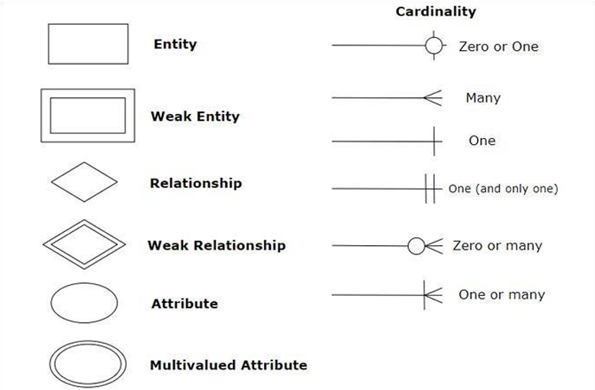

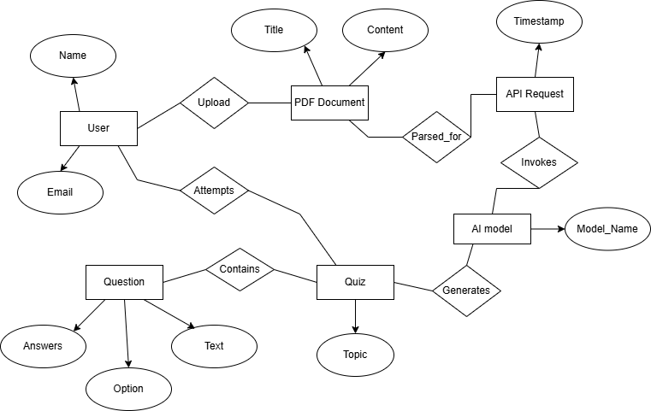

**Figure 1: Entity Relationship Diagram**

#### A2: Use Case Diagram

In the Unified Modeling Language (UML), a use case diagram can summarize the details of your system's users (also known as actors) and their interactions with the system. To build one, you'll use a set of specialized symbols and connectors. An effective use case diagram can help your team discuss and represent:

* Scenarios in which your system or application interacts with people, organizations, or external systems.
* Goals that your system or application helps those entities (known as actors) achieve.
* The scope of your system.

Use case diagram components include:

* **Actors:** The users that interact with a system. An actor can be a person, an organization, or an outside system that interacts with your application or system. They must be external objects that produce or consume data.
* **System:** A specific sequence of actions and interactions between actors and the system. A system may also be referred to as a scenario.
* **Goals:** The end result of most use cases. A successful diagram should describe the activities and variants used to reach the goal.

A use case diagram doesn't go into a lot of detail—for example, don't expect it to model the order in which steps are performed. Instead, a proper use case diagram depicts a high-level overview of the relationship between use cases, actors, and systems. Experts recommend that use case diagrams be used to supplement a more descriptive textual use case.

UML is the modeling toolkit that you can use to build your diagrams. Use cases are represented with a labeled oval shape. Stick figures represent actors in the process, and the actor's participation in the system is modeled with a line between the actor and use case. To depict the system boundary, draw a box around the use case itself.

UML use case diagrams are ideal for:

* Representing the goals of system-user interactions.
* Defining and organizing functional requirements in a system.
* Specifying the context and requirements of a system.
* Modeling the basic flow of events in a use case.

The notation for a use case diagram is pretty straightforward and doesn't involve as many types of symbols as other UML diagrams. You can use this guide to learn how to draw a use case diagram if you need a refresher. Here are all the shapes you will be able to find:

* **Use cases:** Horizontally shaped ovals that represent the different uses that a user might have.
* **Actors:** Stick figures that represent the people actually employing the use cases.
* **Associations:** A line between actors and use cases. In complex diagrams, it is important to know which actors are associated with which use cases.
* **System boundary boxes:** A box that sets a system scope to use cases. All use cases outside the box would be considered outside the scope of that system. For example, Psycho Killer is outside the scope of occupations in the chainsaw example found below.
* **Packages:** A UML shape that allows you to put different elements into groups. Just as with component diagrams, these groupings are represented as file folders.

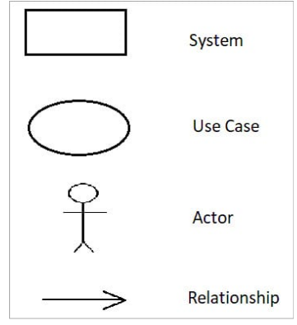

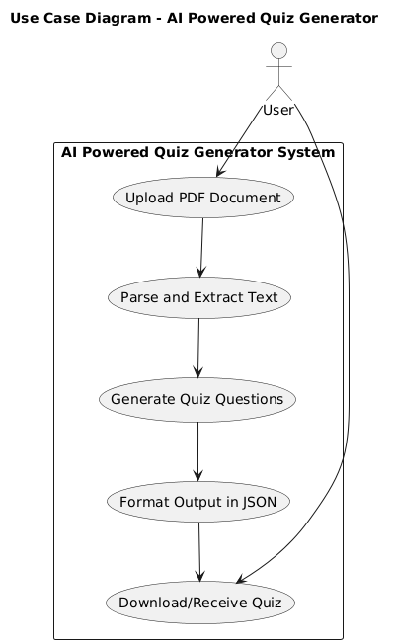

**Figure 2: Use Case Diagram**

#### A3: Data Flow Diagram

Data flow diagram is the starting point of the design phase that functionally decomposes the requirements specification. A DFD consists of a series of bubbles joined by lines. The bubbles represent data transformation and the lines represent data flows in the system. A DFD describes what data flow rather than how they are processed, so it does not hardware, software and data structure. A data-flow diagram (DFD) is a graphical representation of the "flow" of data through an information system. DFDs can also be used for the visualization of data processing (structured design).

The data flow diagram is a graphical description of a system's data and how to Process transform the data is known as Data Flow Diagram (DFD). Unlike details flow chart, DFDs don't supply detail descriptions of modules that graphically describe a system's data and how the data interact with the system. A data flow diagram (DFD) is a significant modeling technique for analyzing and constructing information processes. DFD literally means an illustration that explains the course or movement of information in a process. DFD illustrates this flow of information in a process based on the inputs and outputs. A DFD can be referred to as a Process Model.

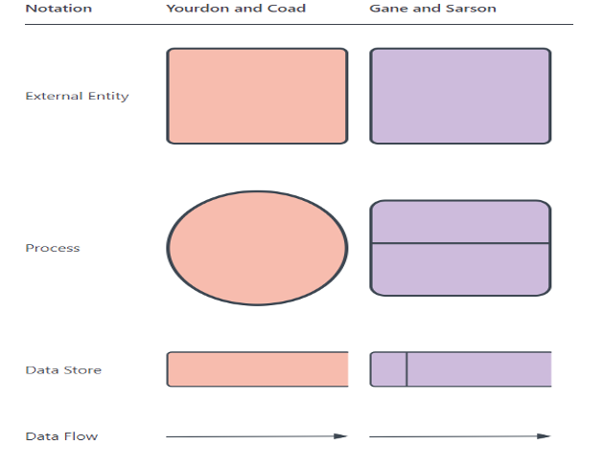

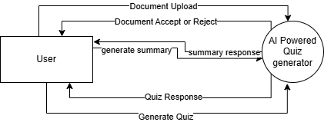

**Figure 3: Level 0- Data Flow Diagram**

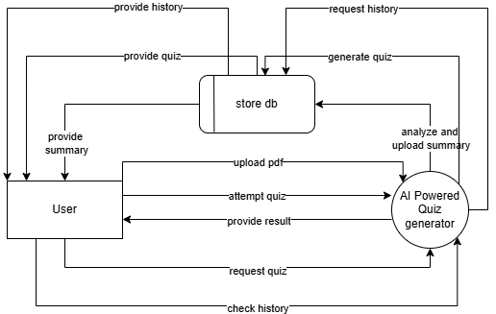

**Figure 4: Level 1- Data Flow Diagram**

#### A4: Class Diagram

Class diagram is a static diagram. It represents the static view of an application. Class diagram is not only used for visualizing, describing, and documenting different aspects of a system but also for constructing executable code of the software application. Class diagram describes the attributes and operations of a class and also the constraints imposed on the system. The class diagrams are widely used in the modeling of object-oriented systems because they are the only UML diagrams, which can be mapped directly with object-oriented languages. Class diagram shows a collection of classes, interfaces, associations, collaborations, and constraints. It is also known as a structural diagram.

The purpose of class diagram is to model the static view of an application. Class diagrams are the only diagrams which can be directly mapped with object-oriented languages and thus widely used at the time of construction.

UML diagrams like activity diagram, sequence diagram can only give the sequence flow of the application, however class diagram is a bit different. It is the most popular UML diagram in the coder community. The purpose of the class diagram can be summarized as –

* Analysis and design of the static view of an application.
* Describe responsibilities of a system.

Base for component and deployment diagrams.

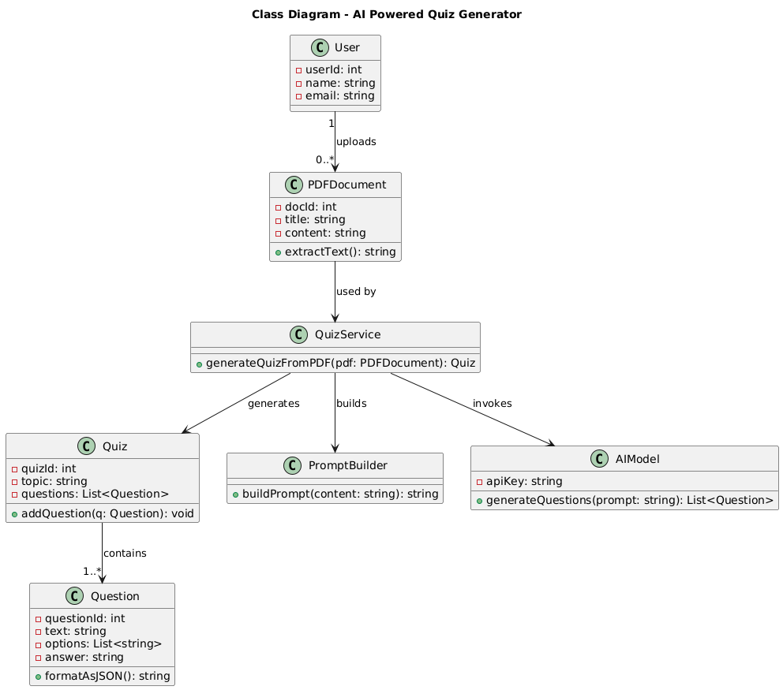

**Figure 5: Class Diagram**

#### A5: Activity Diagram

Activity Diagrams describe how activities are coordinated to provide a service which can be at different levels of abstraction. Typically, an event needs to be achieved by some operations, particularly where the operation is intended to achieve a number of different things that require coordination, or how the events in a single use case relate to one another, in particular, use cases where activities may overlap and require coordination. It is also suitable for modeling how a collection of use cases coordinate to represent business workflows. Before you begin making an activity diagram, you should first understand its makeup. Some of the most common components of an activity diagram include:

* **Action:** A step in the activity wherein the users or software perform a given task.
* **Decision node:** A conditional branch in the flow that is represented by a diamond. It includes a single input and two or more outputs.
* **Control flows:** Another name for the connectors that show the flow between steps in the diagram.
* **Start node:** Symbolizes the beginning of the activity. The start node is represented by a black circle.
* **End node:** Represents the final step in the activity. The end node is represented by an outlined black circle.

Activity diagrams present a number of benefits to users. We consider creating an activity diagram to:

* Demonstrate the logic of an algorithm.
* Describe the steps performed in a UML use case.
* Illustrate a business process or workflow between users and the system.
* Simplify and improve any process by clarifying complicated use cases.
* Model software architecture elements, such as method, function, and operation.

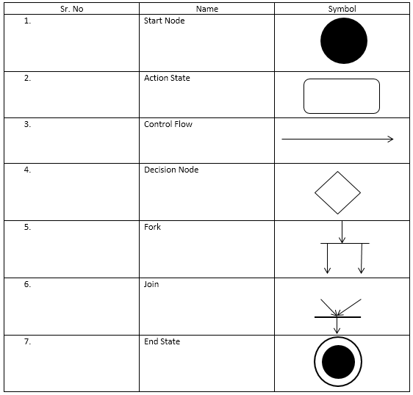

#### 

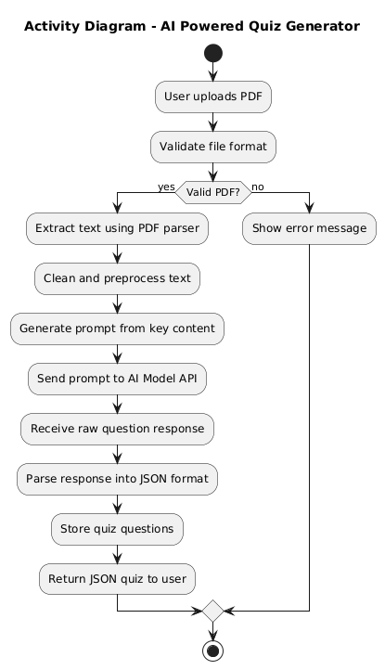

**Figure 6: Activity Diagram**

#### A6: High-Level Architecture Overview

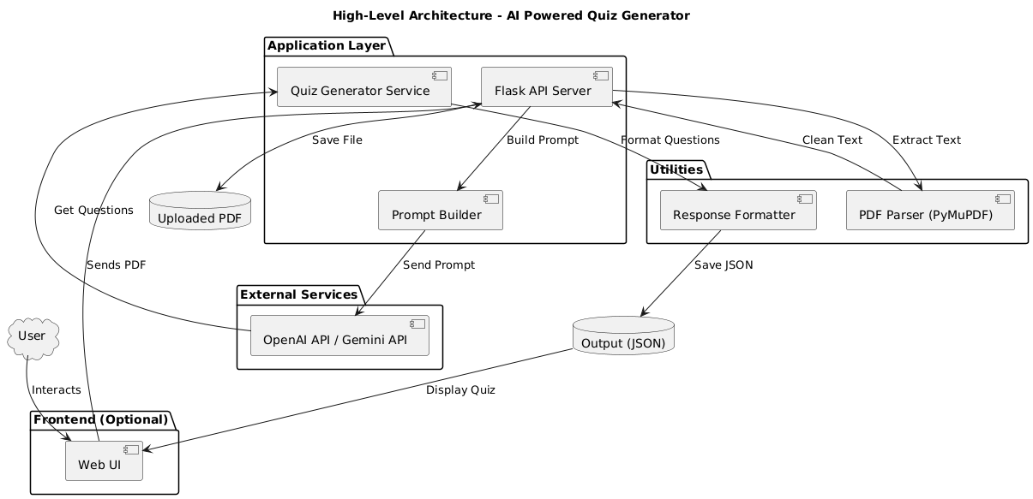

#### A8: Sample Output and Screens

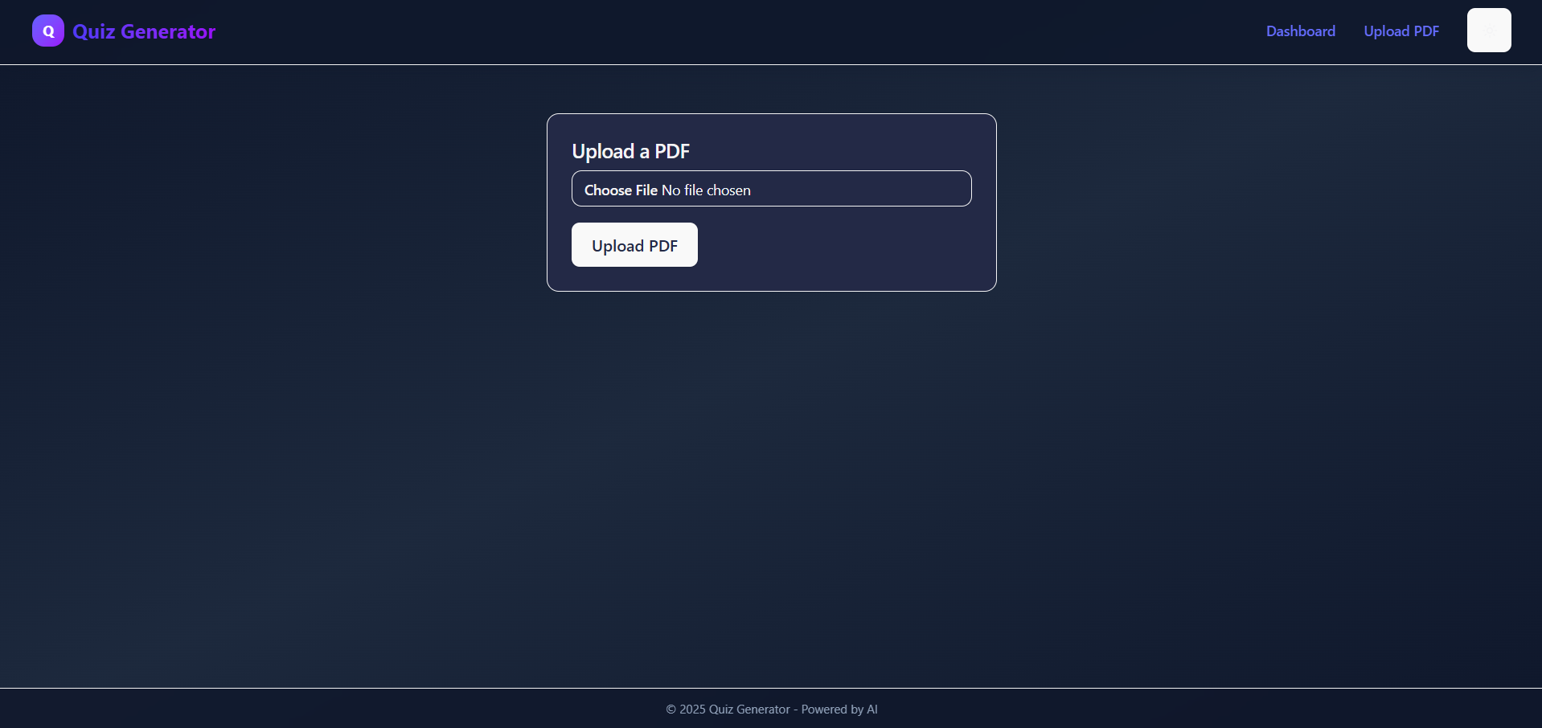

PDF Upload Page

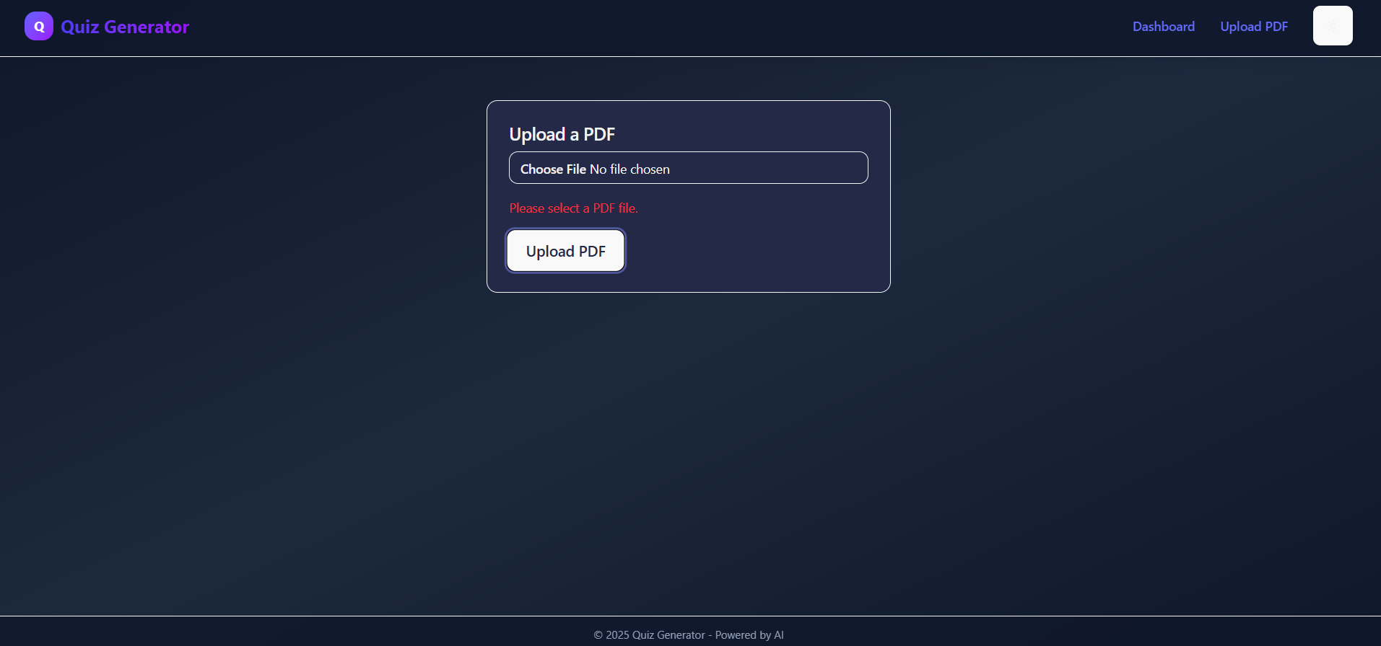

PDF Upload Page (No PDF Selected)

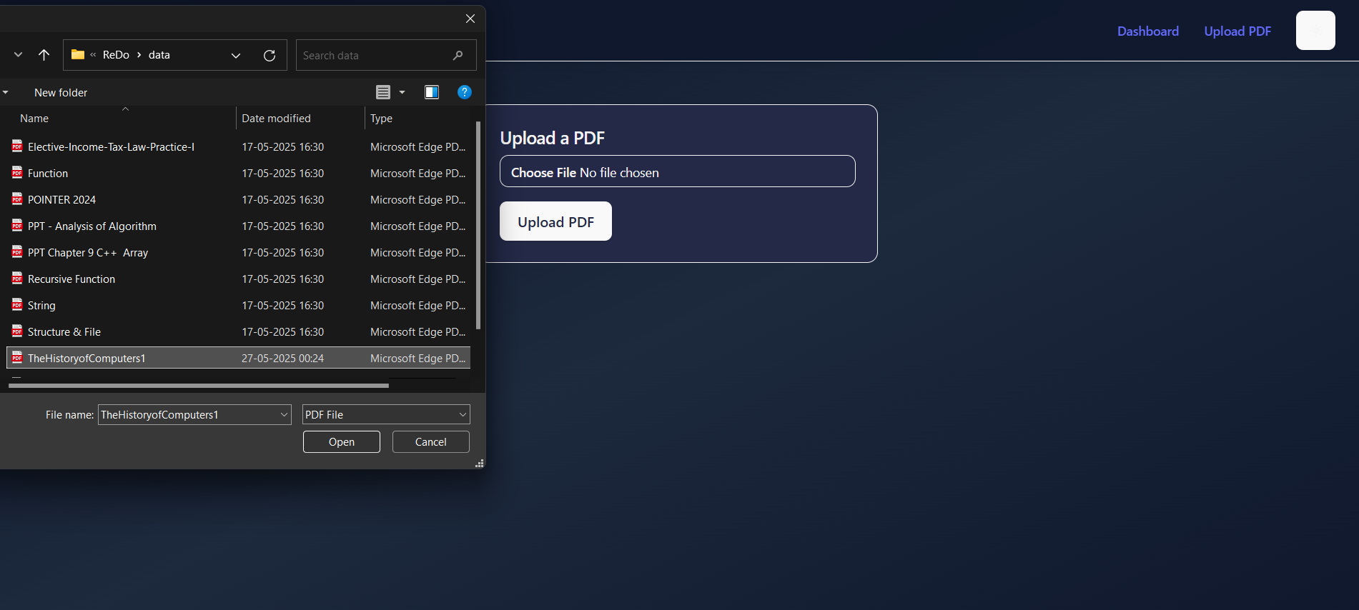

Select PDF

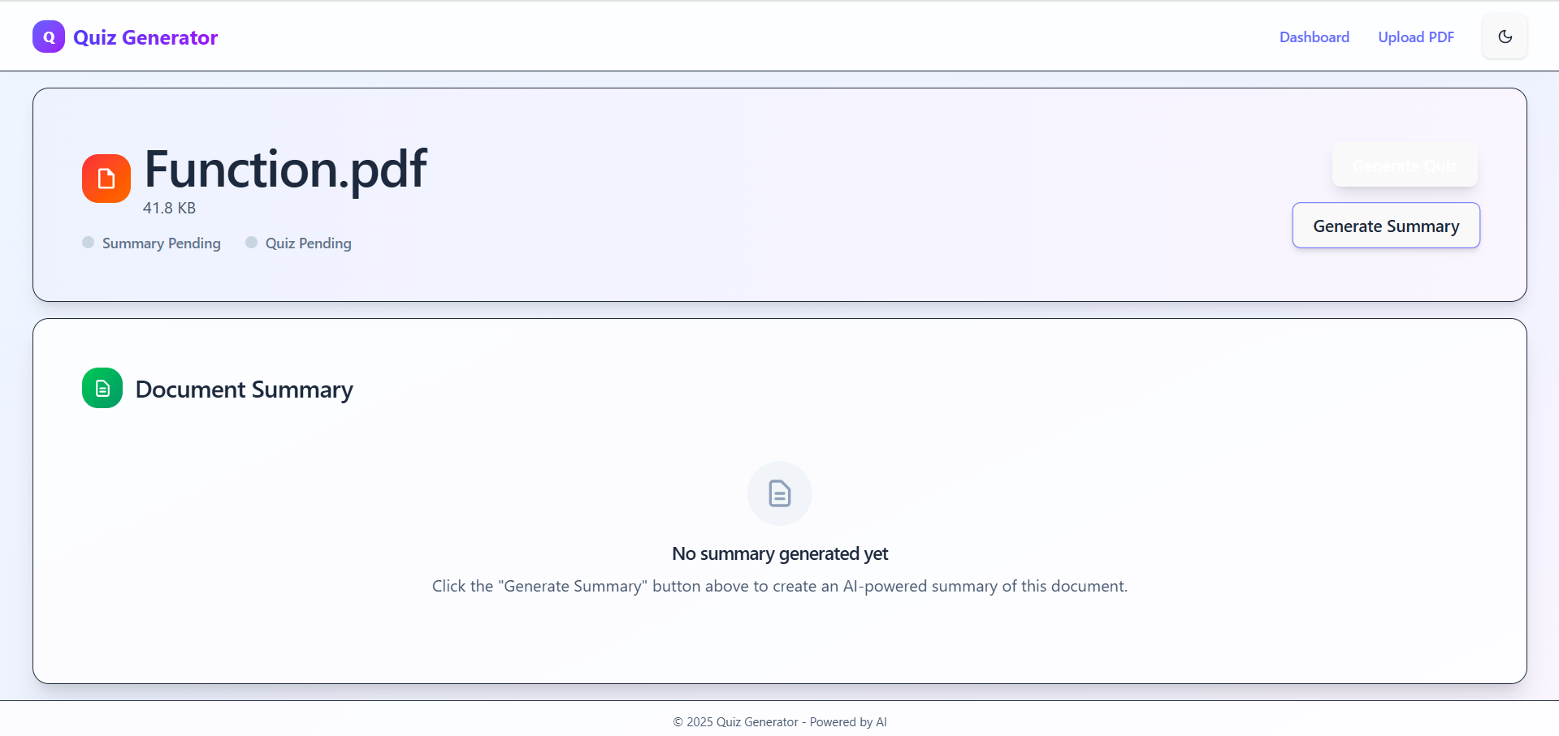

PDF Selected Light Theme

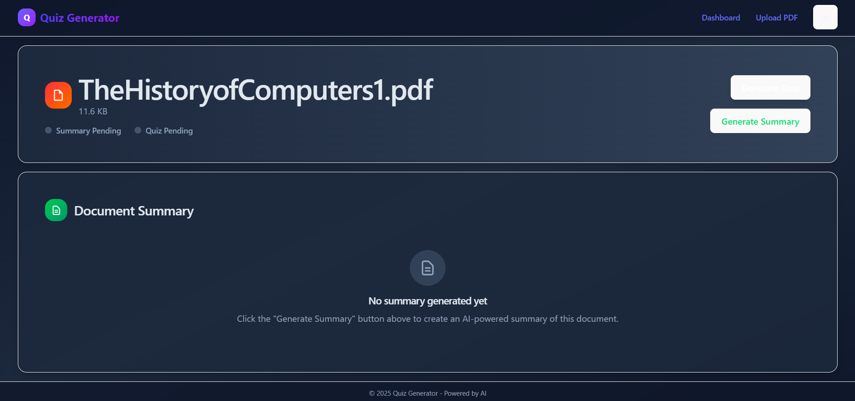

PDF Selected Dark Theme

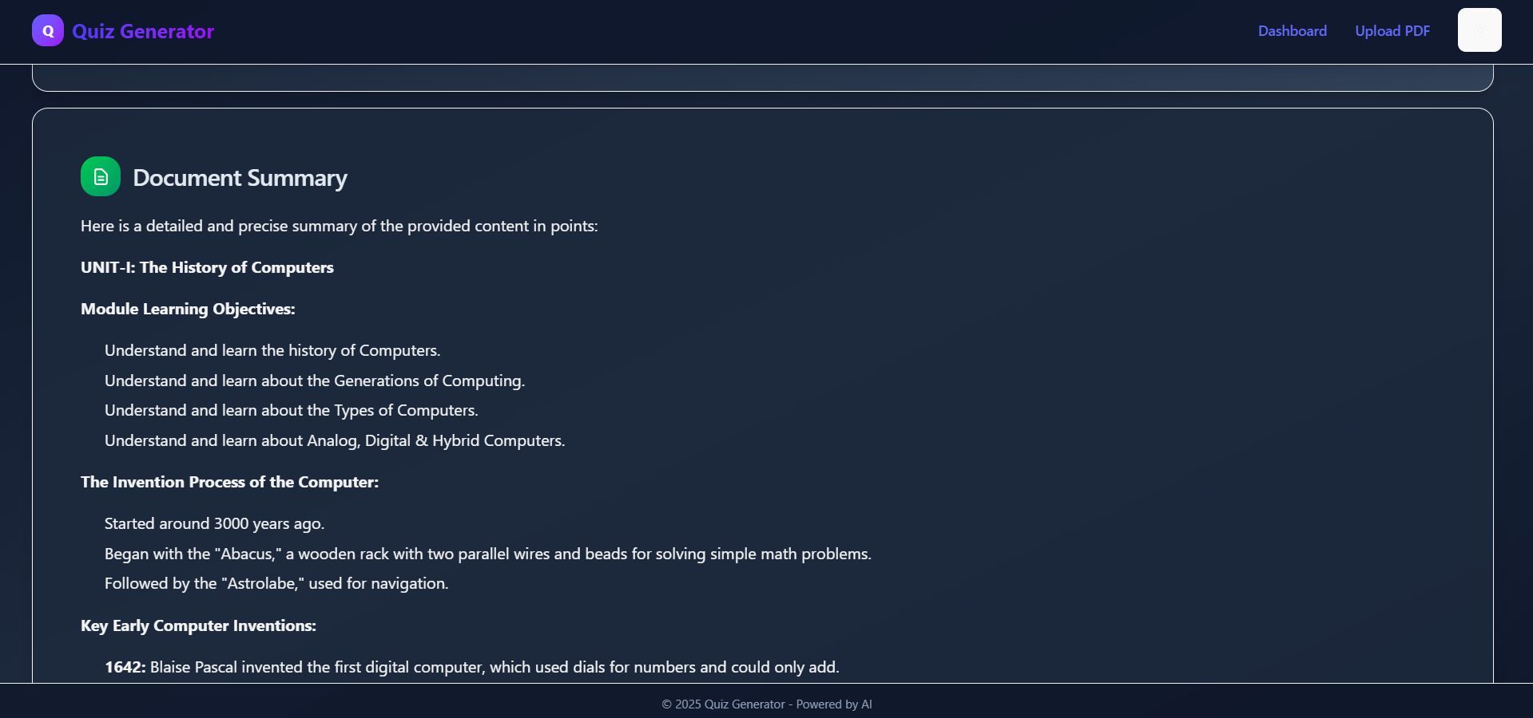

Summary Generated

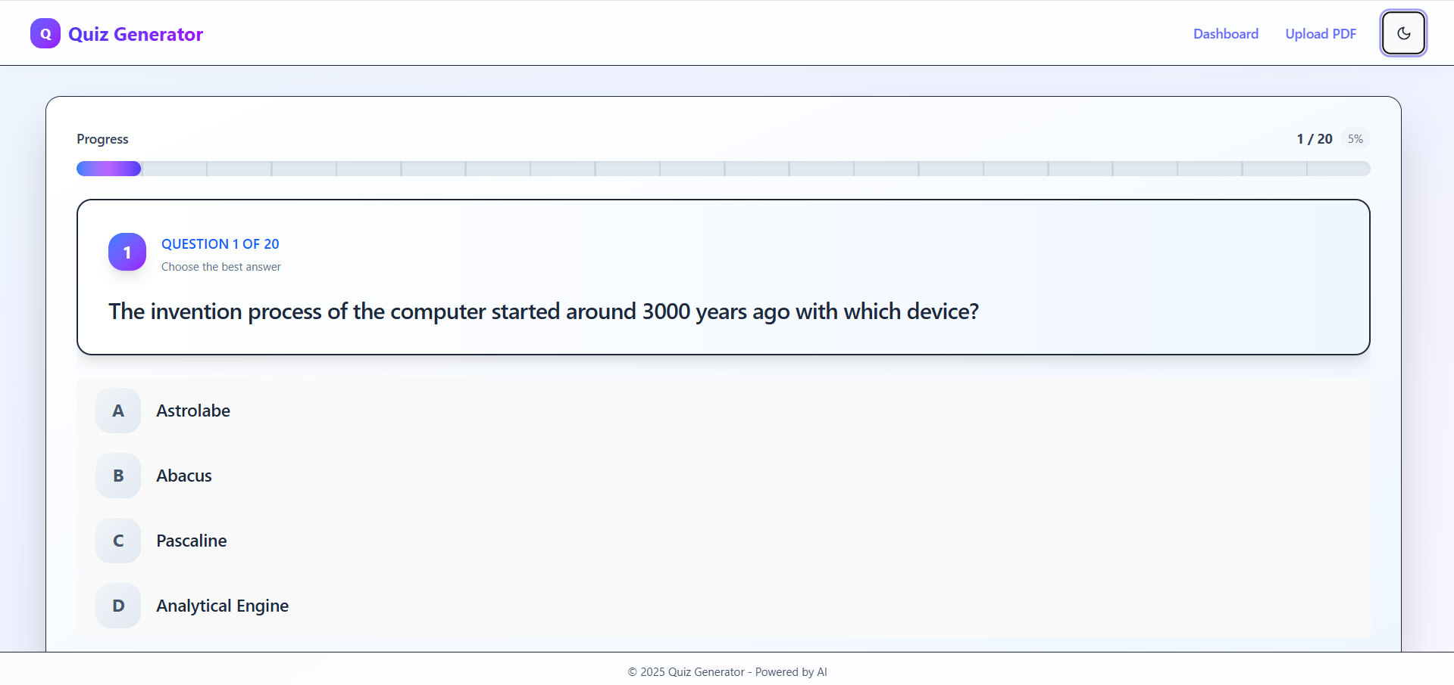

Quiz Generated

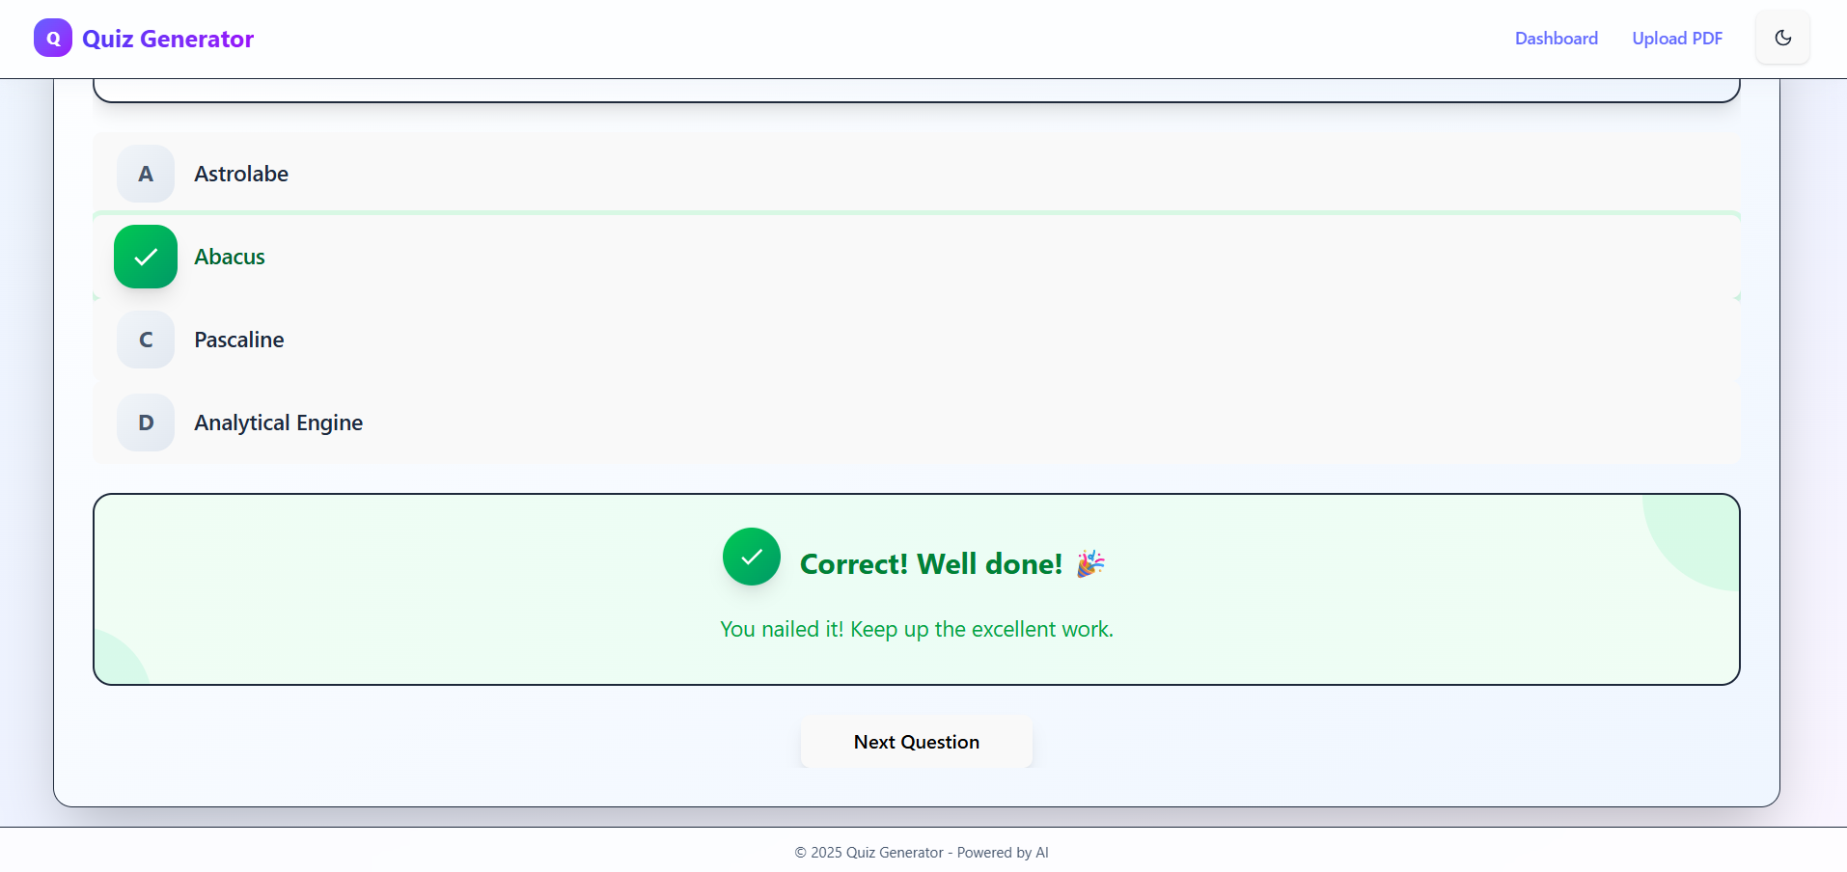

Correct Option

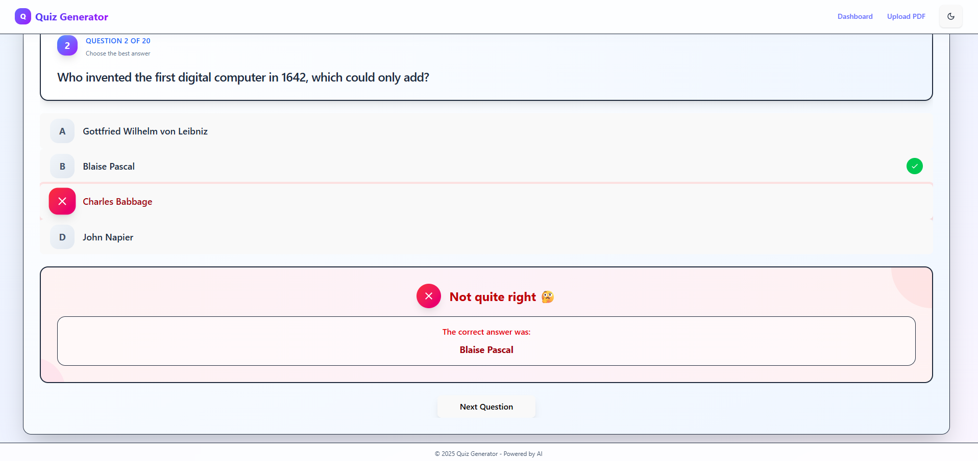

Wrong Option

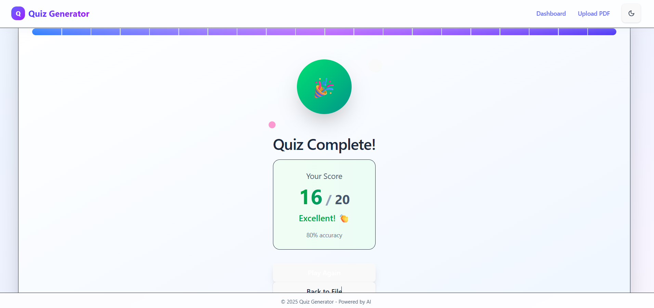

Final Score



Dashboard